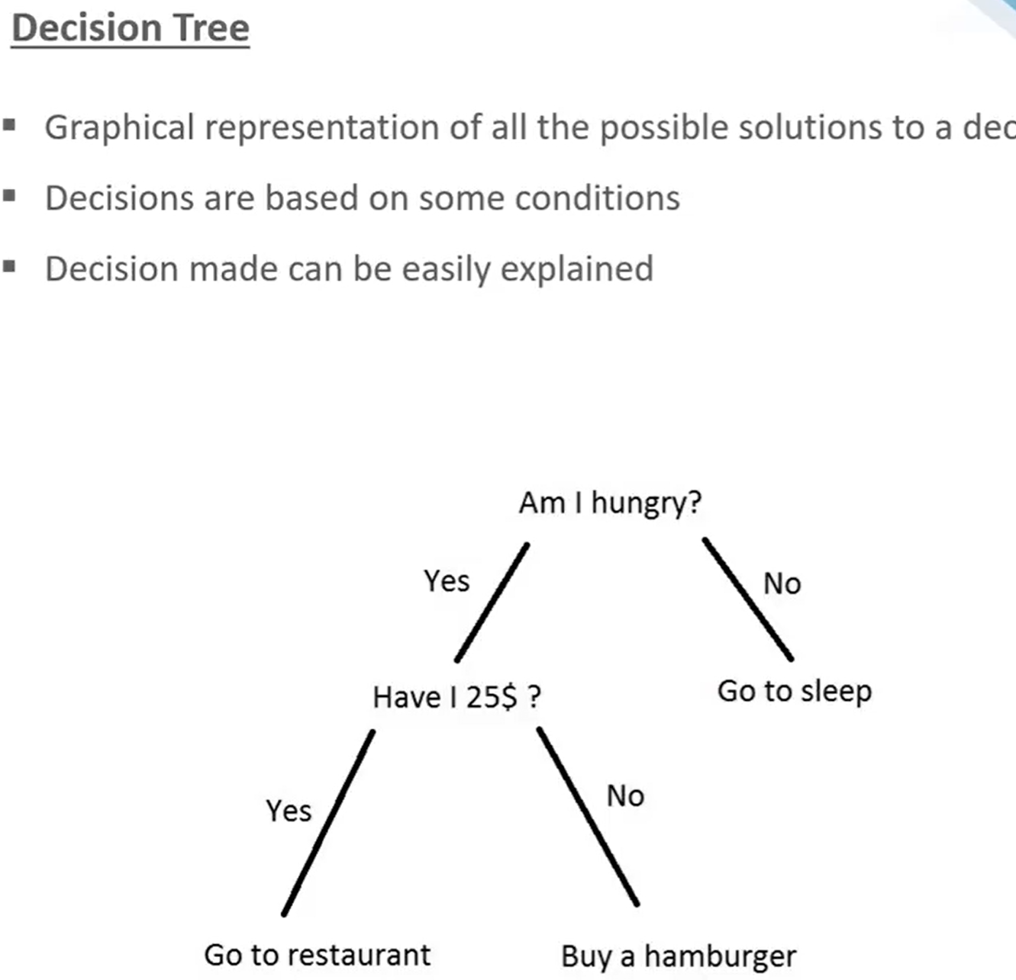

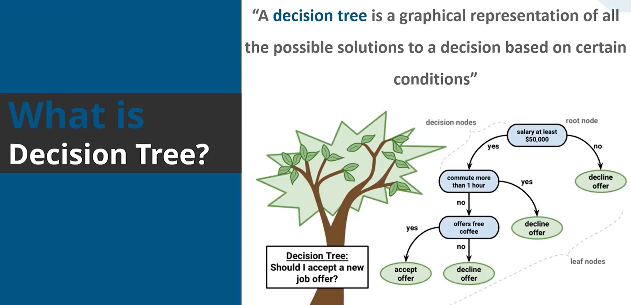
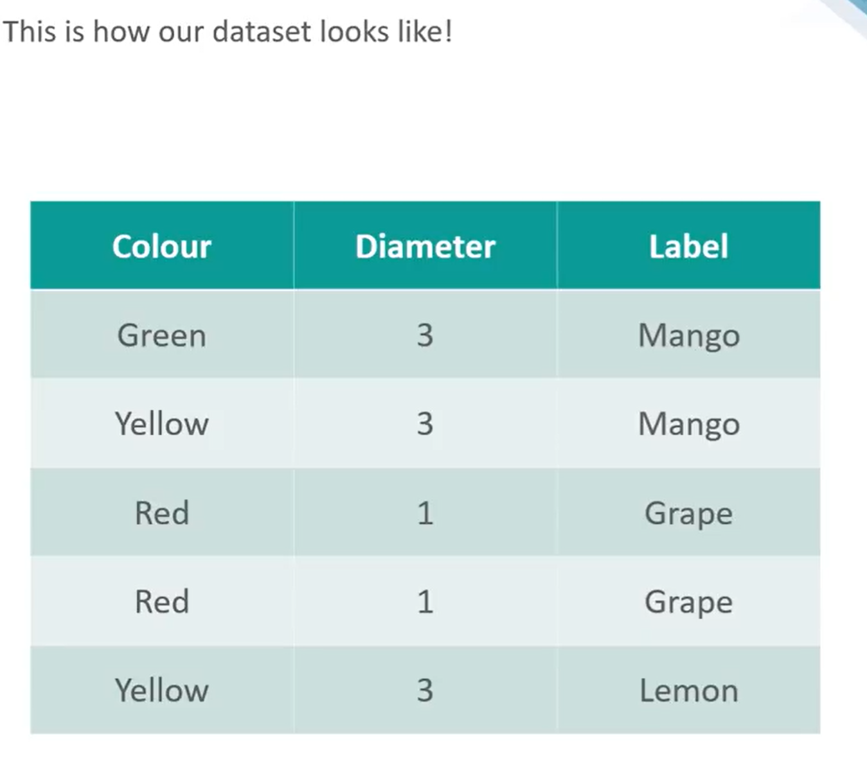

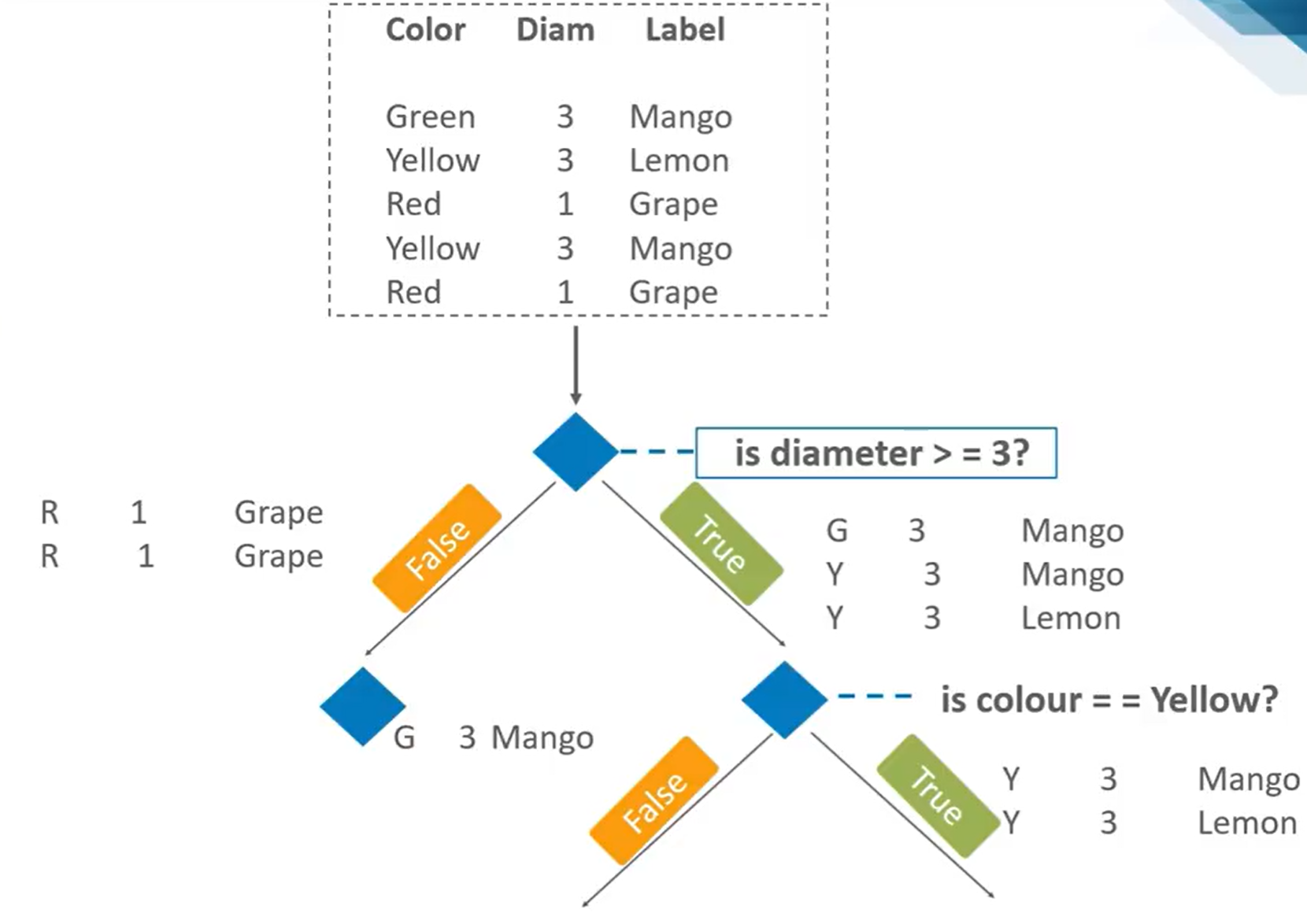
🌳 1. What does “asking questions” mean?
In a decision tree, each question = a split on a feature.
Example:
- “Is Age > 30?”
- “Is Income High?”
- “Did customer click ad?”
Each question divides the data into smaller groups.

🎯 2. Why do we ask questions?
We ask questions to:
👉 Reduce uncertainty
👉 Separate different classes (labels)
At the start:
- Data is “mixed” (e.g., Yes/No labels together)
Goal:
- Make groups as “pure” as possible

📊 3. Measuring Uncertainty → Gini Impurity
Gini impurity tells us:
👉 How mixed the labels are at a node
Formula:
$$Gini=1-∑p_{i}^{2}$$
Where:
- $p_{i}$= probability of class $i$

🧠 Intuition:
- Gini = 0 → Pure (all same class ✅)
- Gini = high → Mixed ❌
Example:
Node Data | Gini
100% Yes | 0
50% Yes, 50% No | 0.5

❓ 4. Which question should we ask?
We try different questions and choose the best one.
👉 Best question = one that reduces impurity the most

📉 5. Measuring “Best Question” → Information Gain
Information Gain tells us:
👉 How much uncertainty is reduced after a split
Formula:
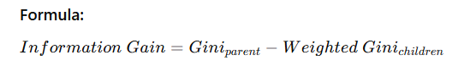

🧠 Interpretation:
- High Information Gain → Good question ✅
- Low Information Gain → Useless question ❌

🔢 6. How many questions do we ask?
We keep asking questions until:
Stop conditions:
- Node becomes pure (Gini = 0)
- No useful split left
- Tree depth limit reached
- Minimum samples reached
👉 So there is no fixed number of questions
🔁 7. Complete Process (Step-by-Step)
- Start with all data
- Compute Gini impurity
- Try all possible questions
- Compute Information Gain for each
- Pick the best question
- Split data
- Repeat for each child node
💡 Simple Analogy
Think of it like asking:
- “Is it an animal?”
- “Does it have wings?”
- “Does it fly?”
Each question:
👉 reduces confusion
👉 gets closer to the correct answer

Dataset
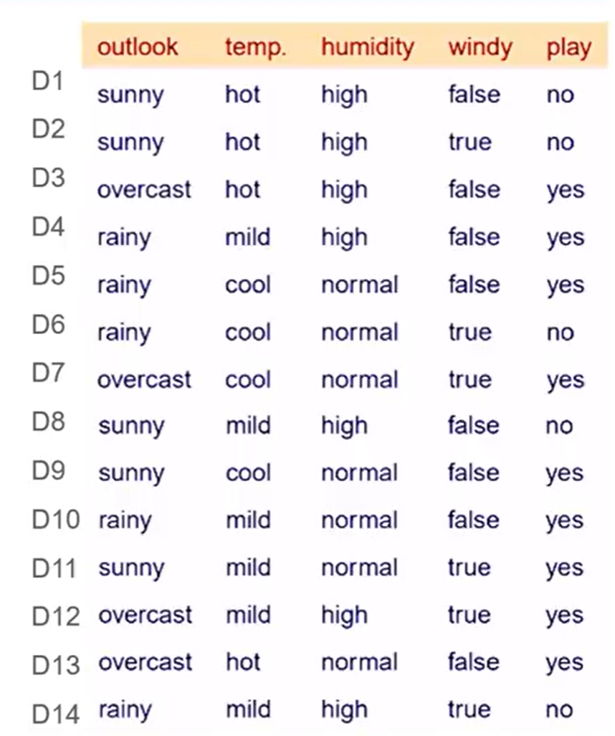
Target column: play
Total records = 14
- Yes = 9
- No = 5
We will choose splits using:
$$Gini(D)=1-∑p_{i}^{2}$$
For two classes:
$$Gini(D)=1-p(yes)^{2}-p(no)^{2}$$
And for a split:
$$Gini_{split}=∑\frac{∣D_{j}∣}{∣D∣}Gini(D_{j})$$
Best split = smallest weighted Gini after split.
Root node Gini
At the root:
- Yes = 9
- No = 5
$$Gini(root)=1-{\left(\frac{9}{14}\right)}^{2}-{\left(\frac{5}{14}\right)}^{2} \\ =1-\frac{81}{196}-\frac{25}{196} \\ =1-\frac{106}{196}=\frac{90}{196}=0.459$$
So root impurity is:
$$\boxed{Gini(root)=0.459}$$

Try all attributes at the root
We test:
- outlook
- temp
- humidity
- windy

Split on outlook

Possible values:
- sunny = 5 rows
- overcast = 4 rows
- rainy = 5 rows
(a) sunny subset
- Yes = 2
- No = 3
$Gini\left(sunny\right)=1-{\left(\frac{2}{5}\right)}^{2}-{\left(\frac{3}{5}\right)}^{2}=$0.48
(b) overcast subset
- Yes = 4
- No = 0
$$Gini(overcast)=1-{\left(\frac{4}{4}\right)}^{2}-{\left(\frac{0}{4}\right)}^{2}=1-1=0$$
(c) rainy subset
- Yes = 3
- No = 2
$$Gini\left(rainy\right)=1-{\left(\frac{3}{5}\right)}^{2}-{\left(\frac{2}{5}\right)}^{2}=0.48$$
(d) Weighted Gini for outlook
$$Gini(outlook)=\frac{5}{14}(0.48)+\frac{4}{14}(0)+\frac{5}{14}\left(0.48\right)=\frac{10}{14}(0.48)=0.343$$
So:
$$\boxed{Gini_{split}(outlook)=0.343}$$Split on temp

Possible values:
hot = 4
mild = 6
cool = 4
(a) hot subset
Yes = 2
No = 2
$$Gini(hot)=1-{\left(\frac{2}{4}\right)}^{2}-{\left(\frac{2}{4}\right)}^{2}=1-\frac{1}{4}-\frac{1}{4}=0.5$$(b) mild subset
Yes = 4
No = 2
$$Gini(mild)=1-{\left(\frac{4}{6}\right)}^{2}-{\left(\frac{2}{6}\right)}^{2}=1-\frac{16}{36}-\frac{4}{36}=1-\frac{20}{36}=\frac{16}{36}=0.444$$
Yes = 3
No = 1
$$Gini(cool)=1-{\left(\frac{3}{4}\right)}^{2}-{\left(\frac{1}{4}\right)}^{2}=1-\frac{9}{16}-\frac{1}{16}=1-\frac{10}{16}=\frac{6}{16}=0.375$$
$Gini(temp)=\frac{4}{14}(0.5)+\frac{6}{14}(0.444)+\frac{4}{14}(0.375)$ $=0.440$
So:
$$\boxed{Gini_{split}(temp)=0.440}$$
Split on humidity

Possible values:
- high = 7
- normal = 7
(a) high subset
- Yes = 3
- No = 4
$$Gini(high)=1-{\left(\frac{3}{7}\right)}^{2}-{\left(\frac{4}{7}\right)}^{2}=1-\frac{9}{49}-\frac{16}{49}=1-\frac{25}{49}=\frac{24}{49}=0.490$$
(b) normal subset
- Yes = 6
- No = 1
$$Gini(normal)=1-{\left(\frac{6}{7}\right)}^{2}-{\left(\frac{1}{7}\right)}^{2}=1-\frac{36}{49}-\frac{1}{49}=1-\frac{37}{49}=\frac{12}{49}=0.245$$
(c) Weighted Gini for humidity
$$Gini(humidity)=\frac{7}{14}(0.490)+\frac{7}{14}(0.245) \\ =0.245+0.1225=0.3675$$
So:
$$\boxed{Gini_{split}(humidity)=0.367}$$

Split on windy

Possible values:
- false = 8
- true = 6
(a) false subset
- Yes = 6
- No = 2
$$Gini(false)=1-{\left(\frac{6}{8}\right)}^{2}-{\left(\frac{2}{8}\right)}^{2}=1-\frac{36}{64}-\frac{4}{64}=1-\frac{40}{64}=\frac{24}{64}=0.375$$
(b) true subset
- Yes = 3
- No = 3
$$Gini(true)=1-{\left(\frac{3}{6}\right)}^{2}-{\left(\frac{3}{6}\right)}^{2}=1-\frac{1}{4}-\frac{1}{4}=0.5$$
(c) Weighted Gini for windy
$$Gini(windy)=\frac{8}{14}(0.375)+\frac{6}{14}(0.5) \\ =0.214+0.214=0.428$$
So:
$$\boxed{Gini_{split}(windy)=0.429}$$

Compare all root splits
- outlook = 0.343
- temp = 0.440
- humidity = 0.367
- windy = 0.429
Best split is the smallest value.
So root node is:
rainy

$$\boxed{outlook}$$
overcast

Sunny
temp | humidity | windy | play
hot | high | false | no
hot | high | true | no
mild | high | false | no
cool | normal | false | yes
mild | normal | true | yes

temp | humidity | windy | play
mild | high | false | yes
cool | normal | false | yes
cool | normal | true | no
mild | normal | false | yes
mild | high | true | no

temp | humidity | windy | play
hot | high | false | yes
cool | normal | true | yes
mild | high | true | yes
hot | normal | false | yes

🌥️ Branch 1: outlook = overcast
temp | humidity | windy | play
hot | high | false | yes
cool | normal | true | yes
mild | high | true | yes
hot | normal | false | yes

$Gini(D)=1-p(yes)^{2}-p(no)^{2}$ = $1-(4/4)^{2}$=0

☀️ Branch 2: outlook = sunny
temp | humidity | windy | play
hot | high | false | no
hot | high | true | no
mild | high | false | no
cool | normal | false | yes
mild | normal | true | yes

Target: play
- no = 3
- yes = 2
Gini of whole dataset
$$Gini(D)=1-{\left(\frac{3}{5}\right)}^{2}-{\left(\frac{2}{5}\right)}^{2}=1-\frac{9}{25}-\frac{4}{25}=1-\frac{13}{25}=\frac{12}{25}=0.48$$Check each attribute
Split on temp
Values: hot, mild, cool
temp = hot
$$Gini(hot)=1-{\left(\frac{2}{2}\right)}^{2}-{\left(\frac{0}{2}\right)}^{2}=0$$ temp = mild
$$Gini(mild)=1-{\left(\frac{1}{2}\right)}^{2}-{\left(\frac{1}{2}\right)}^{2}=1-\frac{1}{4}-\frac{1}{4}=\frac{1}{2}=0.5$$
temp = cool
$$Gini(cool)=0$$
Weighted Gini:
$$Gini(temp)=\frac{2}{5}(0)+\frac{2}{5}(0.5)+\frac{1}{5}(0) \\ =\frac{1}{5}=0.2$$

Split on humidity
Values: high, normal
humidity = high
$$Gini(high)=0$$
humidity = normal
$$Gini(normal)=0$$
Weighted Gini:
$$Gini(humidity)=\frac{3}{5}(0)+\frac{2}{5}(0)=0$$

Split on windy
Values: false, true
windy = false
$$Gini(false)=1-{\left(\frac{2}{3}\right)}^{2}-{\left(\frac{1}{3}\right)}^{2} \\ =1-\frac{4}{9}-\frac{1}{9}=\frac{4}{9}$$
windy = true
$$Gini(true)=1-{\left(\frac{1}{2}\right)}^{2}-{\left(\frac{1}{2}\right)}^{2}=0.5$$
Weighted Gini:
$$Gini(windy)=\frac{3}{5}⋅\frac{4}{9}+\frac{2}{5}⋅\frac{1}{2} \\ =\frac{4}{15}+\frac{1}{5}=\frac{4}{15}+\frac{3}{15}=\frac{7}{15}≈0.467$$
Choose the best split
Compare:
- $\text{Gini(temp)}=0.2$
- $\text{Gini(humidity)}=0$
- $\text{Gini(windy)}≈0.467$
The smallest Gini is for humidity.

🌧️ Branch 3: outlook = rainy
temp | humidity | windy | play
mild | high | false | yes
cool | normal | false | yes
cool | normal | true | no
mild | normal | false | yes
mild | high | true | no

Target: play
- yes = 3
- no = 2
Gini of whole dataset
$$Gini(D)=1-{\left(\frac{3}{5}\right)}^{2}-{\left(\frac{2}{5}\right)}^{2} \\ =1-\frac{9}{25}-\frac{4}{25}=\frac{12}{25}=0.48$$
Split on each attribute
Split on temp
Values: mild, cool

temp = mild
$$Gini(mild)=1-{\left(\frac{2}{3}\right)}^{2}-{\left(\frac{1}{3}\right)}^{2} \\ =1-\frac{4}{9}-\frac{1}{9}=\frac{4}{9}$$temp = cool
$$Gini(cool)=1-{\left(\frac{1}{2}\right)}^{2}-{\left(\frac{1}{2}\right)}^{2}=1-\frac{1}{4}-\frac{1}{4}=\frac{1}{2}$$Weighted Gini:
$$Gini(temp)=\frac{3}{5}⋅\frac{4}{9}+\frac{2}{5}⋅\frac{1}{2} \\ =\frac{4}{15}+\frac{1}{5}=\frac{4}{15}+\frac{3}{15}=\frac{7}{15}≈0.467$$
Split on humidity
Values: high, normal
humidity = high
$$Gini(high)=1-{\left(\frac{1}{2}\right)}^{2}-{\left(\frac{1}{2}\right)}^{2}=\frac{1}{2}$$
humidity = normal
$$Gini(normal)=1-{\left(\frac{2}{3}\right)}^{2}-{\left(\frac{1}{3}\right)}^{2}=\frac{4}{9}$$
Weighted Gini:
$$Gini(humidity)=\frac{2}{5}⋅\frac{1}{2}+\frac{3}{5}⋅\frac{4}{9} \\ =\frac{1}{5}+\frac{4}{15}=\frac{3}{15}+\frac{4}{15}=\frac{7}{15}≈0.467$$
Split on windy
Values: false, true
windy = false
$$Gini(false)=0$$
windy = true
$$Gini(true)=0$$
Weighted Gini:
$$Gini(windy)=\frac{3}{5}(0)+\frac{2}{5}(0)=0$$

Compare:
- $\text{Gini(temp)}=0.467$
- $\text{Gini(humidity)}=0.467$
- $\text{Gini(windy)}=0$
Smallest Gini is: windy

So the root node is windy.

👉 Decision:
So root node is:
$$\boxed{outlook}$$
rainy

overcast

Sunny

humidity

windy
yes

false
true
normal
High

no
no
yes
yes

📌 Final Decision Rules (Very Important for Exams)
- If outlook = overcast → play = yes
- If outlook = sunny and humidity = high → play = no
- If outlook = sunny and humidity = normal → play = yes
- If outlook = rainy and windy = false → play = yes
- If outlook = rainy and windy = true → play = no

